**EXP 11** Demonstrate virtualization by Installing Type -2 Hypervisor in your device, create and configure VM image with a Host Operating system (Either Windows/Linux).

**PROCEDURE:**

**STEP 1** Install VM ware software

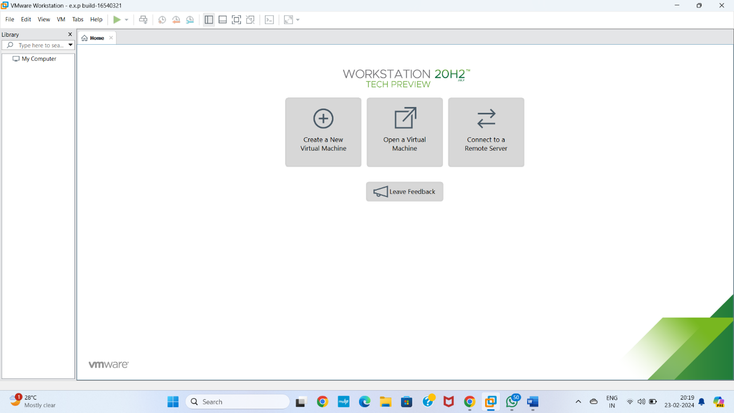

**STEP 2** CREAT A NEW VIRTUAL MACHINE GIVE NEXT

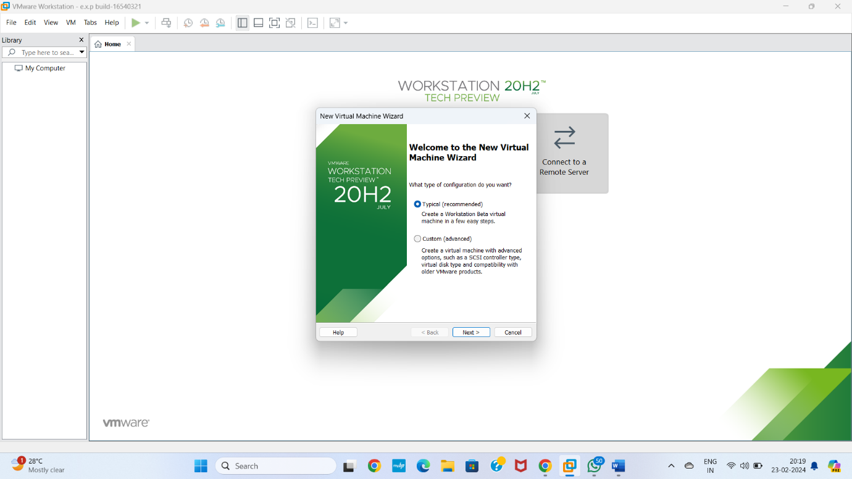

**STEP 3** select INSTALL disc image file Choose browse image file Give next

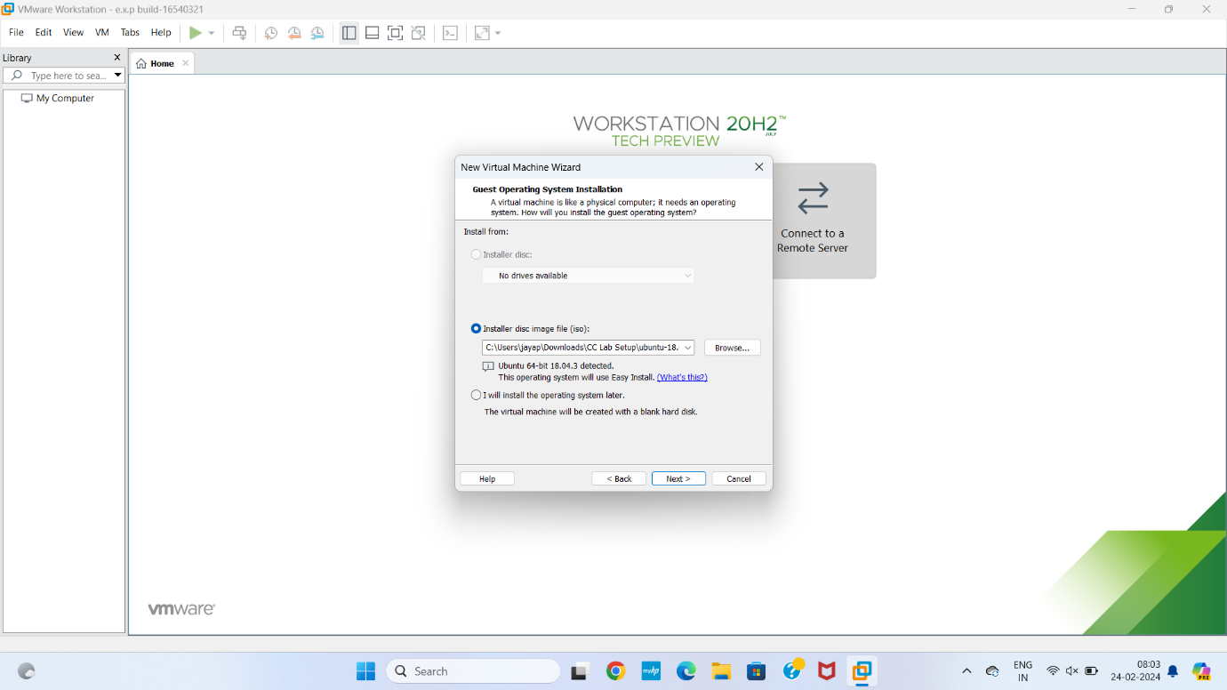

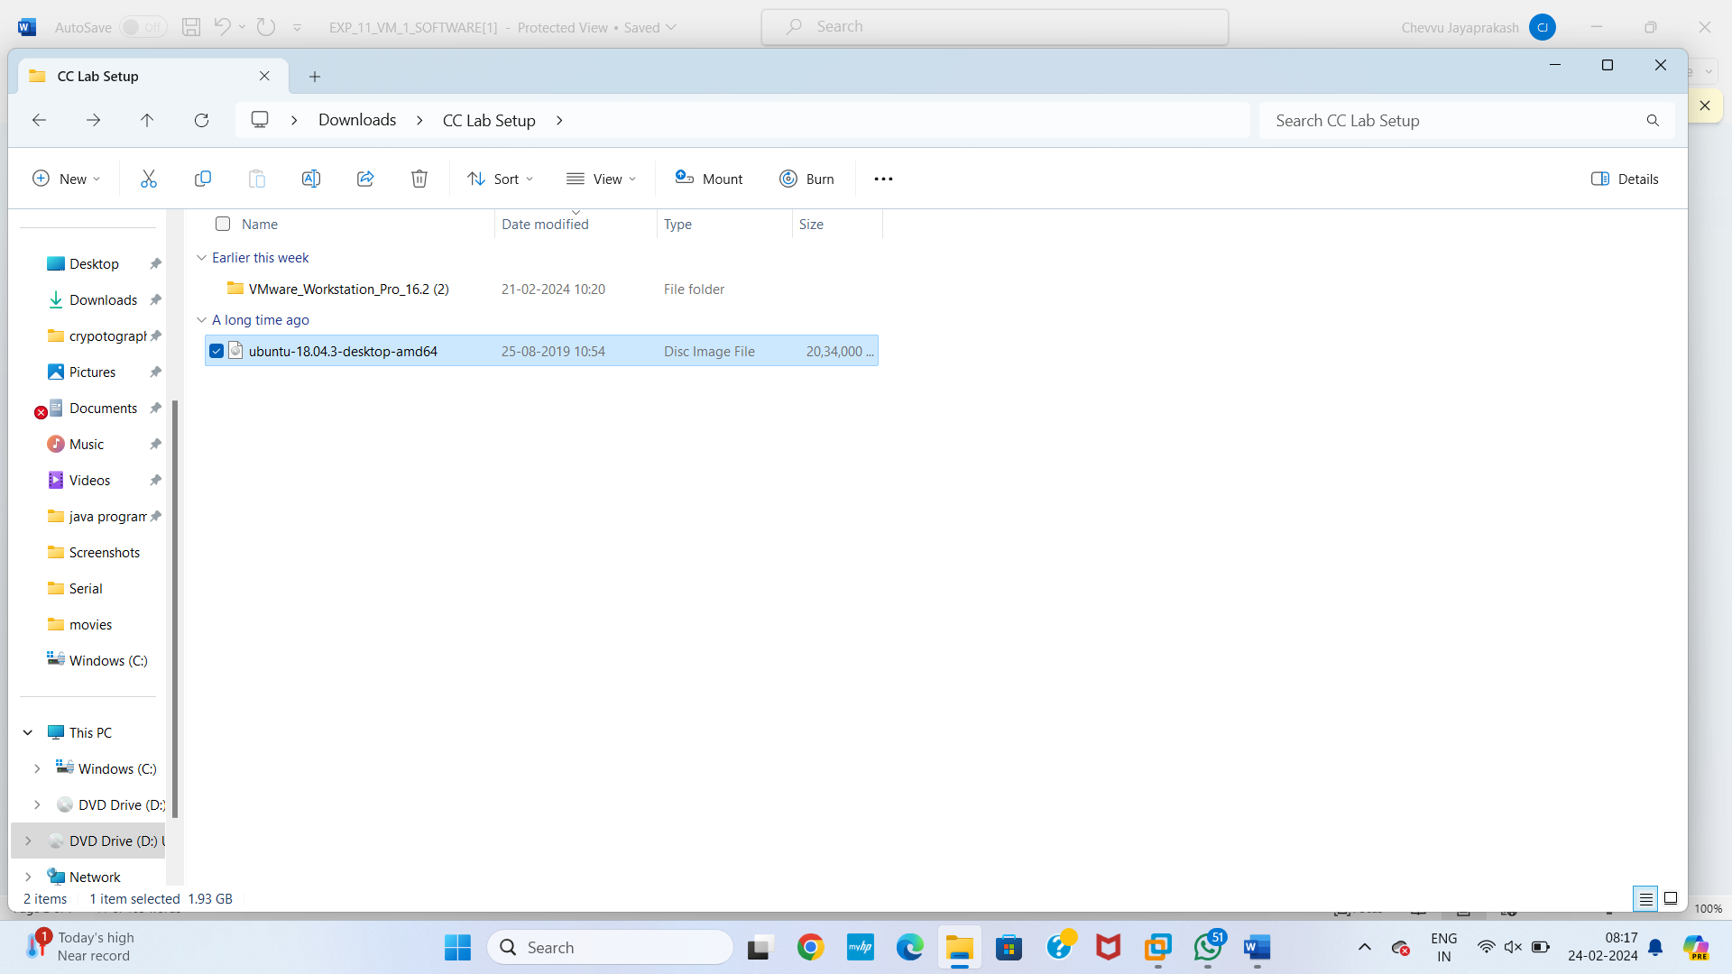

**Step 4** Easy install information

Give next

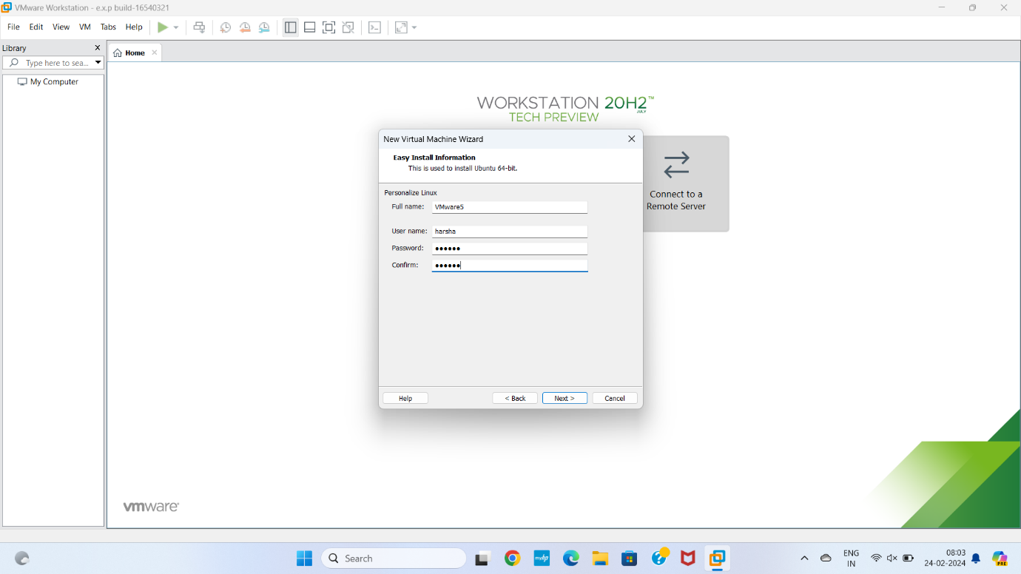

**Step 5** Ready to create virtual machine

Give finish

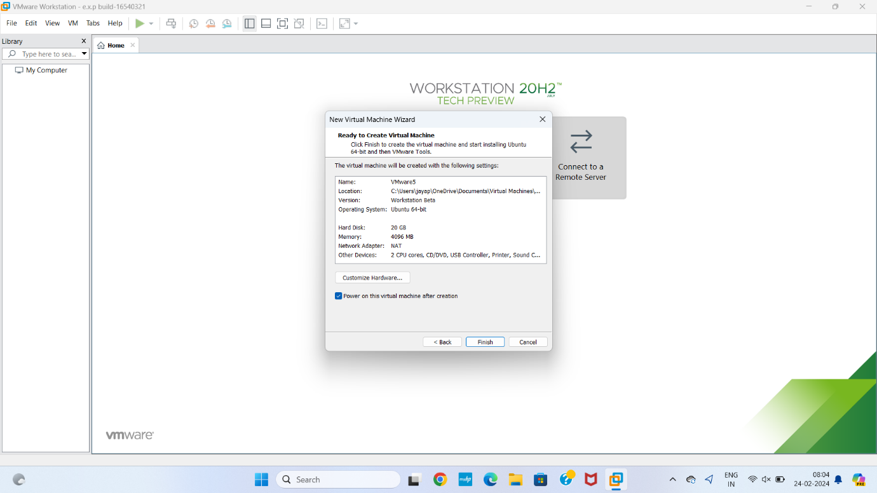

**Step 6** OS installing

Give ok

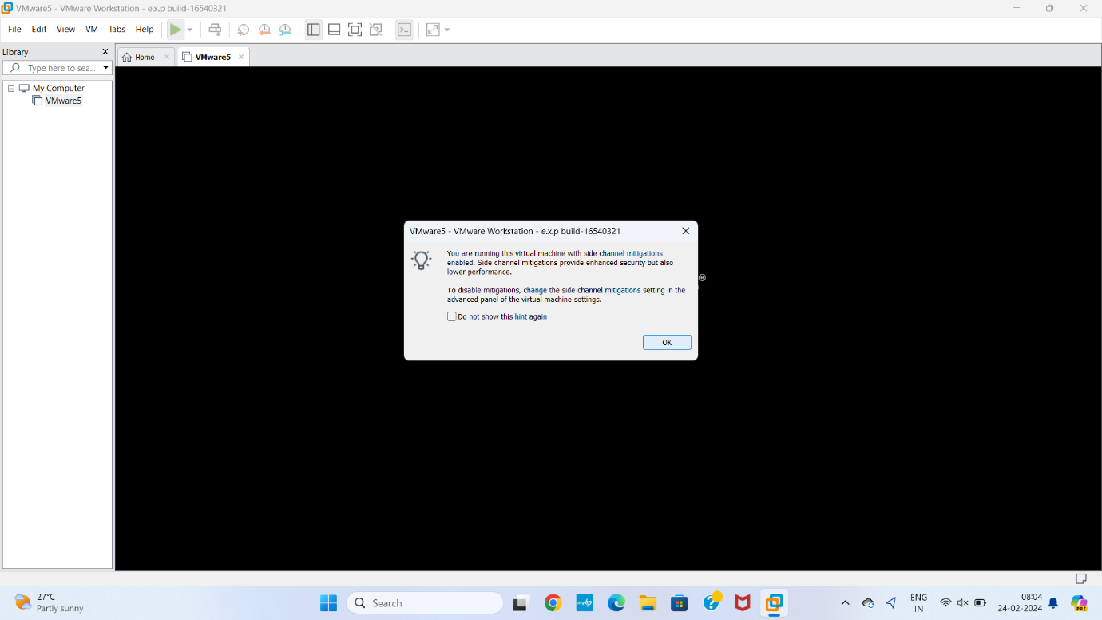

**Step 7:** running program

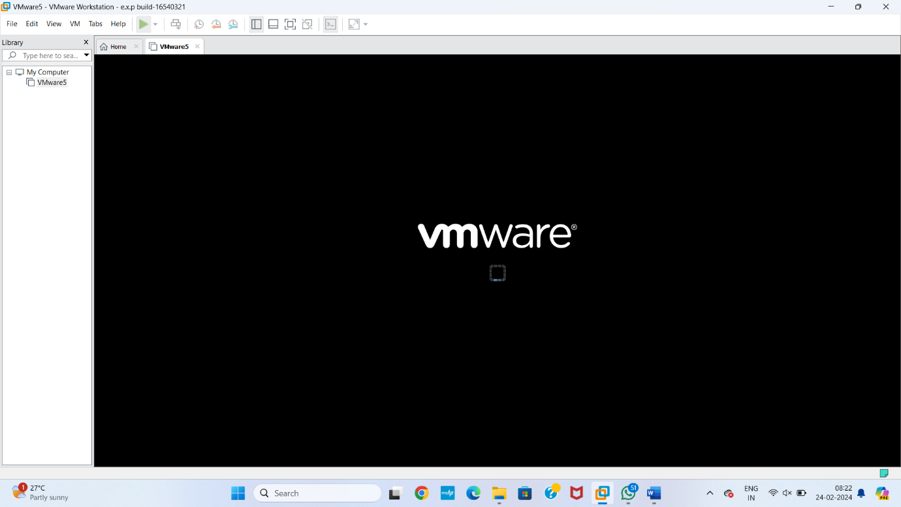

**Step 8** installing software OS

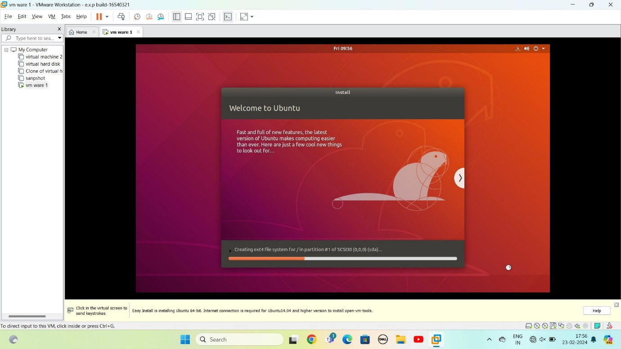

**Step 9** if installation completed

It will ask user name and password

Enter it

It shows screen with apps

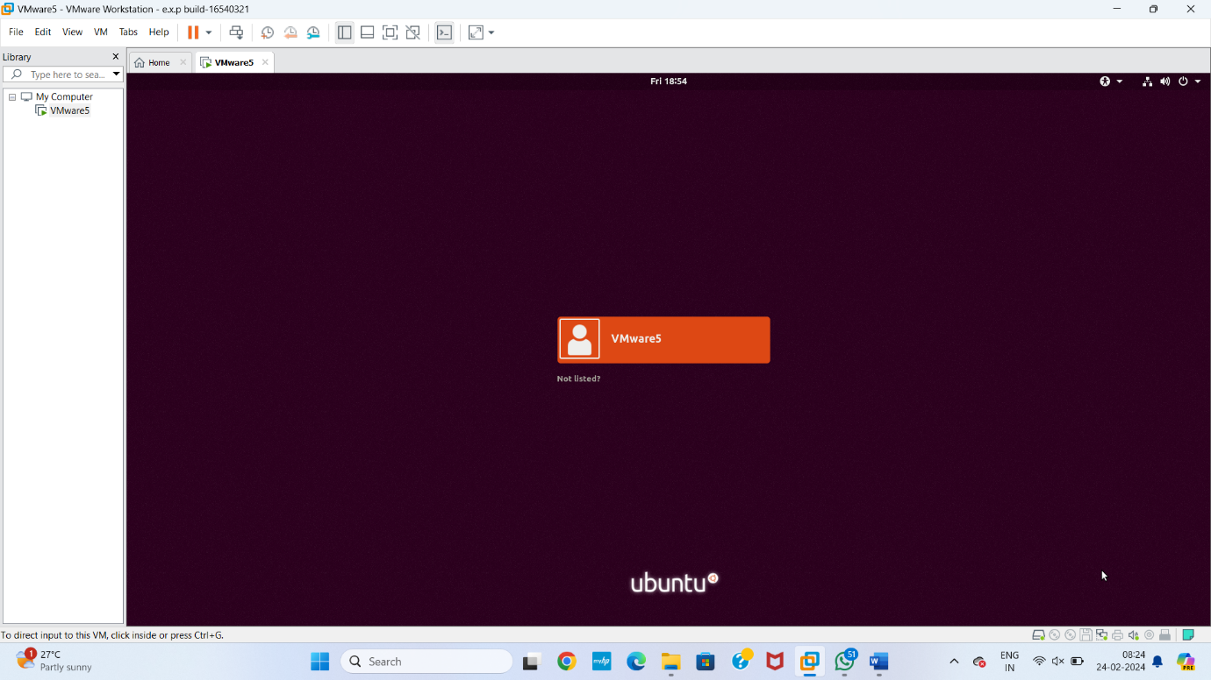

**STEP 10** The ubuntu software installed

